## 

December 2019

Patient Newsletter

alker

edical

roup

W

M

G

**MERRY CHRISTMAS AND A HAPPY NEW YEAR TO ALL**

**OUR PATIENTS**

**CLOSING TIMES FOR CHRISTMAS**

**We will be closed on:**

**25 December**

**26 December**

**1 January**

The normal opening times apply for any other day.

We expect this to be a very busy time of year for our services.

When we are closed and you need emergency help ring 999 and ask for an ambulance for other urgent medical help and advice call the 111 service.



**Telephone lines**

The GPs have taken into consideration the Friends and Family questionnaires and comments from patients saying they were finding it difficult to get through to the surgery via the telephone. Two new telephone lines have now been purchased so there are six lines available for incoming calls and two for outgoing calls.

We hope it will now be easier for patients to contact the surgery. However we will continue to monitor telephone usage and listen to your views.

**PATIENT PARTICIPATION GROUP MEETING**

Our next meeting is on Thursday20 February 2019 at 10.30 a.m.at the surgery. If you would like to attend or are interested in being part of the group please inform the receptionists and they will pass your details on to the practice manager.

ARE YOU ELIGIBLE FOR A FLU JAB AND NOT HAD IT YET?  COME TO ONE OF OUR WALK IN CLINICS – NO APPOINTMENT NECESSARY EVERY **TUESDAY TO FRIDAY EVENING FROM 17:00 UNTIL 17:45.**

**Join the digital first evolution**

eConsult is a new way of accessing our services and lets patients consult with us online by completing a quick form that is sent and reviewed by the practice. Patient can also be directed to self-help, pharmacy advice and local self-referral services.

A robust red flagging system is applied to every patient request. The system is fully compliant and uses the highest security standards to ensure patients’ data is always secure.

Look out for the eConsult flag on our website or ask reception for more information.

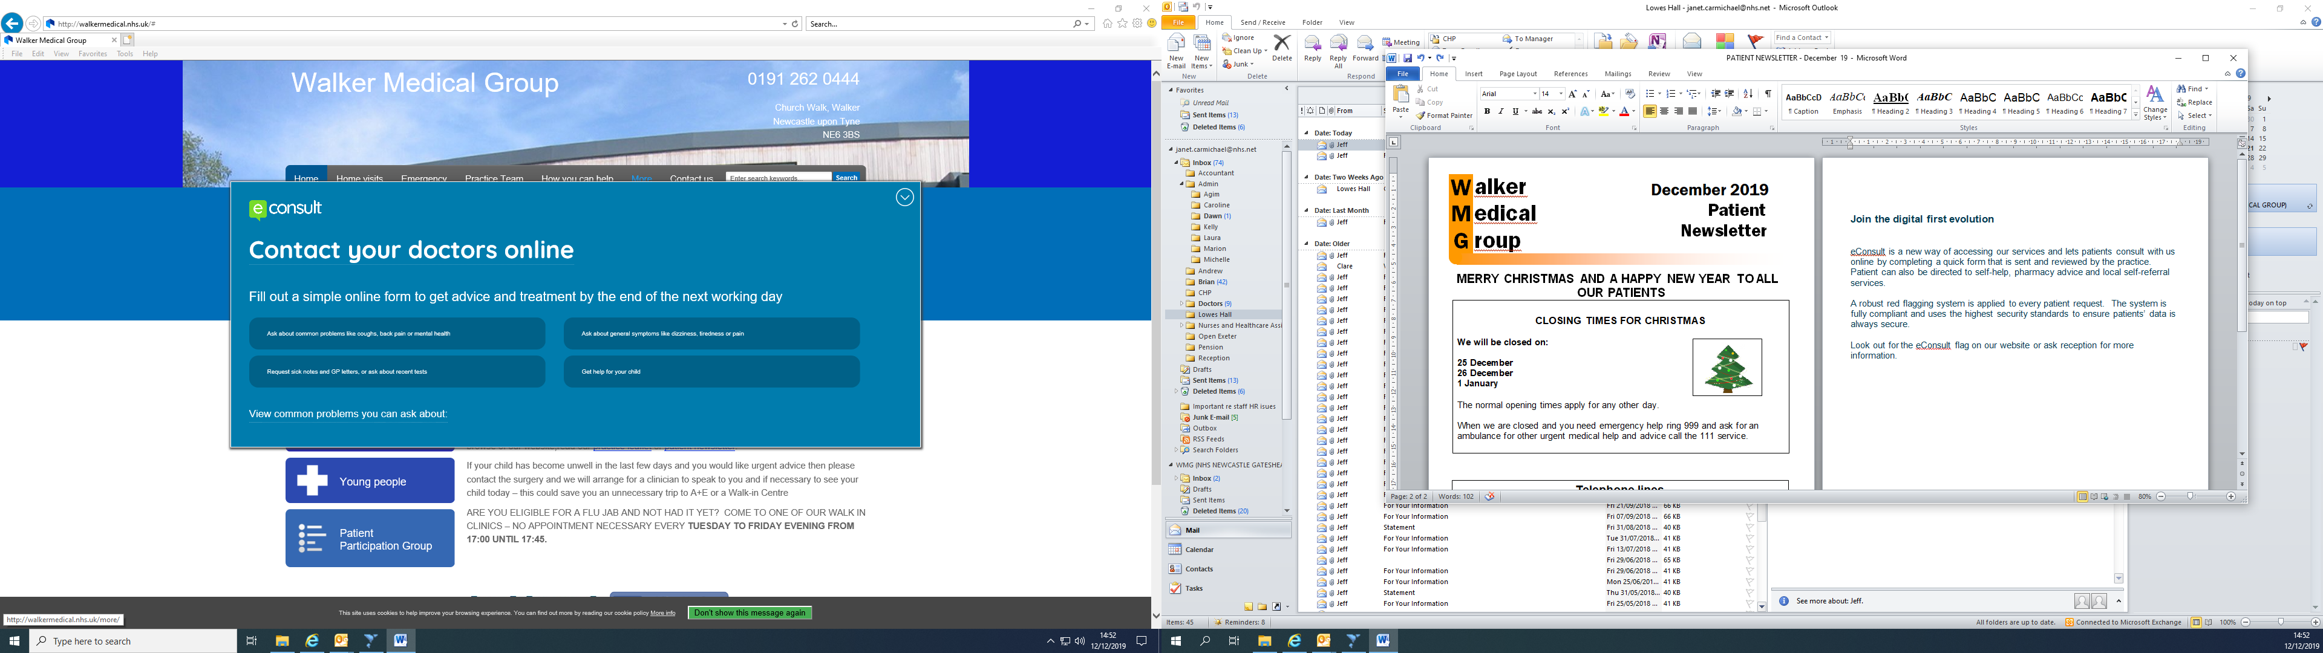

If you have any suggestions for our Newsletter please write down on a piece of paper and pop into the suggestion box or send via the web site.